WEST END CARNIVAL 2024

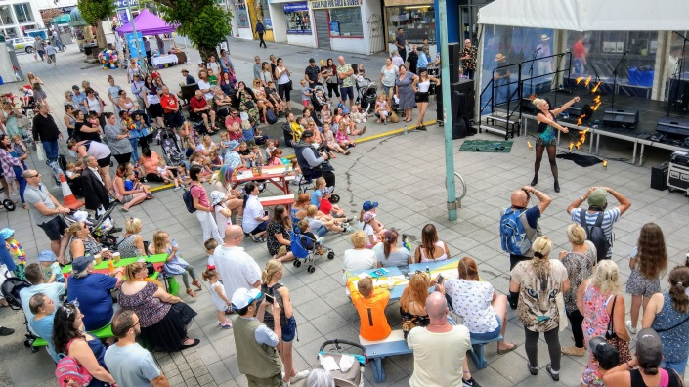
We are delighted to announce this year’s West End Carnival on Saturday August 24th from 11am to 4pm.

This is the perfect opportunity to celebrate with a day of FREE family entertainment and to support our West End businesses at the same time.

This year’s event will feature a ‘Dragons and Mythical Beasts’ theme. The iconic West End parade returns with some new additions; starting from Frankfort Gate and heading up to the Sundial for a performance with a special Dragon guest, before looping back to Frankfort Gate to conclude. Performance areas will be found in Frankfort Gate and throughout the West End.

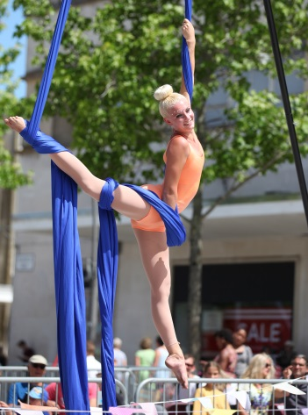
We have a packed line-up of entertainment and activities
across the West End including:

- Carnival parade
- Dragons!
- Live Music
- Circus show and roaming performers
- Samba Band
- Silent Disco
- And more!

If you are interested in being involved in this year’s West End Carnival please complete and return the form below and submit all relevant documentation.

Please note that all traders will need to provide their own gazebo, table and chairs.

A site fee of £60 will be charged for a standard 3m x 3m space, but there will be no power supply via electrical connection unless agreed otherwise with the lead officer.

Traders will be positioned on arrival however you will be located in the west end area.

No vehicles will be allowed to stay on site.

WEST END CARNIVAL TRADER APPLICATION FORM

GENERAL DETAILS

Organisation
Contact Name
Address
Postcode
Contact Number
Email
Vehicle Registration Plate

STALL REQUIREMENTS

What size area do you require? (for example: 3m x 3m; please note maximum available area would be 6m x 3m)
I will bring a small gazebo
Please provide a brief description of your stall:

TRADER CHECKLIST

Documentation required prior to event | Please Tick
Copy of Public liability insurance (Please note, policy cover must be for £5million or over.)
Food Traders - Letter confirming local authority registration or copy of food hygiene rating
Risk Assessment
Complete and Return attached Debtor Form

Documentation required on the stalls during the event | Please Tick
Up to date Public liability insurance (Please note, policy cover must be for £5million or over.)
Employers’ liability insurance will be required if there are five or more staff, including yourself.
Risk Assessment (template available if required)
CFOA Fire Risk Assessment

Additional requirements for traders to be available during the event | Please Tick
Temporary Events Notice (TENS) license (If selling alcohol)
Gas Safety Certificates (If using gas at the event)
Food safety management system (safer food better business or equivalent)
Food Hygiene Training Certificates
Copy food hygiene rating sticker
Organic Certificate (If required)
Food origin information
Allergen information

All applications need to be returned by Friday 26th July 2024 and places will be allocated thereafter.
Please return either by email to lloyd.owen@plymouth.gov.uk

Or by post to: Lloyd Owen
Marketing & Events
Plymouth City Council
Ballard House
West Hoe Road
Plymouth
PL1 3BJ

SOCIAL MEDIA

In the meantime, check out our West End Plymouth website and please like, share and follow our social media channels which were set up to promote the West End and your businesses.

www.westendplymouth.co.uk

F: @WestEndPlymouth
T: @WestEndPlymouth
Insta: @WestEndPlym

Please tag us wherever you can! #WestEndPlymouthCarnival

Please carefully read and sign the terms and conditions outlined below and return with this application form.

West End Carnival Terms & Conditions 2024

Please take time to read through these terms and conditions and discuss any issues you may have with the lead officer.
If you do not following these conditions you will be asked to stop your activity until the problem is rectified. If the problem is such that you are dismissed from site you will not be refunded any fees paid.

GENERAL
- Trading is only permitted within the stated hours:
  - Saturday 24 August 2024 – 11am to 4pm
- All exhibitors must provide copies of their supporting documentation prior to the event. Until full paperwork has been received your booking will remain provisional.
- Whilst every effort will be made to meet the requirements of the Exhibitor/Trader, Plymouth City Council and Plymouth City Centre Company cannot guarantee a particular position. You will be allocated your site on arrival.
- If you are bringing your own gazebo, you must ensure it is appropriately secure and weighted.
- All exhibitors/traders are responsible for the insurance of their own property and goods brought on to the event site. Plymouth City Council accepts no liability for loss or damage incurred whilst exhibitor’s equipment is on site.
- Whilst on site you must adhere to the vehicle movement policy and directions provided.
- Rudeness and aggression towards staff and contractors is not acceptable and will not be tolerated.
- Stall holders are only permitted to run their activity within the allocated pitch site. All equipment must be contained within the stall’s footprint.
- Smoking is prohibited inside any tent or stall.
- Stall holders are to display price lists (if applicable)

DOCUMENTATION
- All exhibitors must provide the following prior to the event. Until this has been received your booking will remain provisional.
- Copy of Public liability insurance (Please note, policy cover must be for£5million or over.)
- Risk Assessment
- Completed Environmental Impact Form
- Signed Terms & Conditions
- All exhibitors will also be required to have copies of the above documentation on their stall during the event.

SECURITY
- All exhibitors are responsible for the insurance of their own property and goods brought on to the event site. Plymouth City Council accepts no liability for loss or damage incurred whilst exhibitors’ equipment is on site. You may wish to insure your property against damage.

Refunds
- Refunds will be made for cancellations received in writing by the 2 August 2024. After this date no refunds will be given.

Site Access
- We will advise you of access points to the site 2 weeks prior to the event.
- Stewards in a hi-vis will control vehicle movements.
- There is a 10mph speed limit for all vehicles on the site. Traders must adhere to the speed limits set.
- No vehicles can be left on site during the event unless agreed prior to the event with the lead officer.
- Whilst on site you must adhere to the vehicle access routes and movement policy and directions provided.
- Only Emergency vehicles will be allowed to enter the site once it is open to the public.

EQUIPMENT HIRE
- No tables or other equipment will be provided unless specifically requested on the application form.
- Any equipment hired from Plymouth City Council must be returned in the condition it was given in and signed in/out. Any loss or failure to sign it back in will result in a loss charge.
- Hire for equipment must be paid prior to the event date. No cash will be handled on site.

HEALTH AND SAFETY
- Every exhibitor is responsible for carrying out a risk assessment of their designated area to ensure that all potential risks are minimised (hazards should be identified and preventative/ protective measures implemented).
- A copy of this risk assessment will be available on the stall

WASTE MANAGEMENT AND PLASTIC POLICY
- All exhibitors must take steps to minimize their waste.
- Litter and rubbish generated during the event by the business must be cleared regularly from the stall and surrounding areas and not allowed to collect at the back of stalls.
- Exhibitors are responsible for the cleanliness of the stand and any waste must be cleared before leaving the event site.
- The following items are banned:
  - Non-biodegradable confetti
  - Glitter
  - Plastic giveaways
  - Sweets in plastic packaging, including lollipops
  - Balloons
  - Lanterns
- The exhibitor must ensure cable tie use is kept to a minimum. Fixings should be using reusable bungees where possible.

DECLARATION
I the undersigned, declare that
- I have read and agree to abide by the terms and conditions set out in this document.

Sign: _________________________ Date: ________________

